OSCN LAB
ASSIGNMENT-4
Name: N. Siri
Roll. No.: 2503B05137
M.TECH CSE (semester -1)

Question:
Write a C++ program to implement Hamming Code for error detection and correction.
Requirements:
- Accept a binary data string as input.
- Determine the number of redundant bits required.
- Insert the redundant bits into appropriate positions (1, 2, 4, 8, …).
- Calculate and set the parity bits using even parity logic.
- Display the final data packet (data bits + redundant bits) to be transmitted.
- Simulate the receiver side to:
  - Recalculate parity bits.
  - Detect if there is any single-bit error.
  - Display the position of the erroneous bit or confirm no error if data is correct.

Code:
#include <iostream>
#include <cmath>
#include <vector>
using namespace std;

int getRedundantBits(int m) {
int r = 0;
while (pow(2, r) < (m + r + 1)) r++;
return r;
}

vector<int> generateHamming(vector<int> data) {
int m = data.size();
int r = getRedundantBits(m);
int total = m + r;

vector<int> hamming(total + 1);
int j = 0;

for (int i = 1; i <= total; i++) {
if ((i & (i - 1)) == 0) {
hamming[i] = 0;
} else {
hamming[i] = data[j++];
}
}

for (int i = 0; i < r; i++) {
int pos = pow(2, i);
int parity = 0;
for (int k = 1; k <= total; k++) {
if (k & pos) parity ^= hamming[k];
}
hamming[pos] = parity;
}

return hamming;
}

int detectError(vector<int> code) {
int total = code.size() - 1;
int r = 0;

while (pow(2, r) <= total) r++;

int errorPos = 0;

for (int i = 0; i < r; i++) {
int pos = pow(2, i);
int parity = 0;
for (int k = 1; k <= total; k++) {
if (k & pos) parity ^= code[k];
}
if (parity != 0) errorPos += pos;
}
return errorPos;
}

int main() {
string input;
cout << "Enter original binary data: ";
cin >> input;

vector<int> data;

// FIXED: works on all compilers
for (int i = 0; i < input.length(); i++) {
data.push_back(input[i] - '0');
}

vector<int> hamming = generateHamming(data);

cout << "\nGenerated Hamming Code: ";
for (int i = 1; i < hamming.size(); i++)
cout << hamming[i];
cout << endl;

string received;
cout << "\nEnter received Hamming Code: ";
cin >> received;

vector<int> rec(received.size() + 1);
for (int i = 1; i <= received.size(); i++)
rec[i] = received[i - 1] - '0';

int errorPos = detectError(rec);

if (errorPos == 0) {
cout << "\nNo error detected.\n";
} else {
cout << "\nError detected at bit position: " << errorPos << endl;
rec[errorPos] ^= 1;

cout << "Corrected Code: ";
for (int i = 1; i < rec.size(); i++)
cout << rec[i];
cout << endl;
}

return 0;
}

Output:
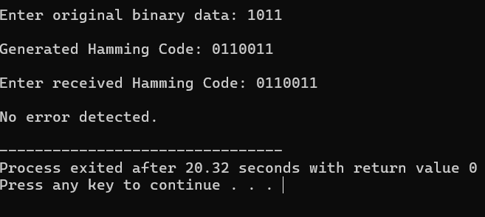
Hamming Code Explanation:
- The data bits are taken as input and the number of redundant (parity) bits required is calculated using the condition
2^r ≥ m + r + 1.
- The redundant bits are placed at positions that are powers of 2, such as 1, 2, 4, 8, etc.
- Each parity bit is calculated using even parity, meaning the total number of 1s in its covered positions must be even.
- The final Hamming code is formed by combining data bits and parity bits and is transmitted to the receiver.
- At the receiver side, parity bits are recalculated; if their combination gives a non-zero value, that position indicates the bit where the error occurred, and the program corrects it.

